**ASSIGNMENT – 3**

| Assignment Date | 05 October 2022 |
| --- | --- |
| Student Name | Divya Rani.R |
| Student Roll Number | 111619104024 |
| Maximum Marks | 2 Marks |

**Building a Regression Model**

1. Download the dataset: Dataset

**data=pd.read_csv("abalone.csv")**

2. Load the dataset into the tool.

**data.head()**

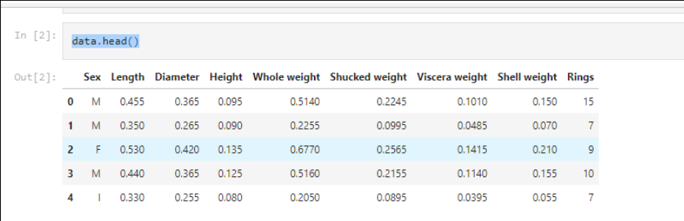

3. Perform Below Visualizations.

∙ Univariate Analysis

***#univariate analysis***

cols **=** 3

rows **=** 3

num_cols **=** data**.**select_dtypes(exclude**=**'object')**.**columns

fig **=** plt**.**figure( figsize**=**(cols**\***5, rows**\***5))

**for** i, col **in** enumerate(num_cols):

ax**=**fig**.**add_subplot(rows,cols,i**+**1)

sns**.**histplot(x **=** data[col], ax **=** ax)

fig**.**tight_layout()

plt**.**show()

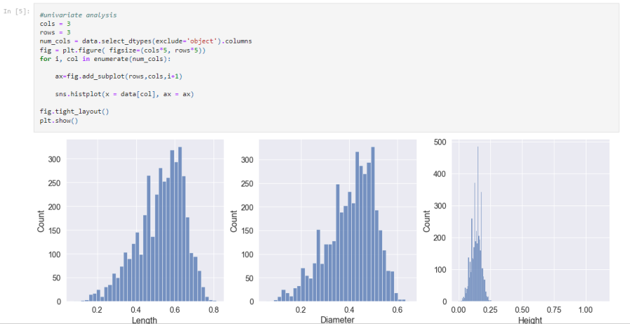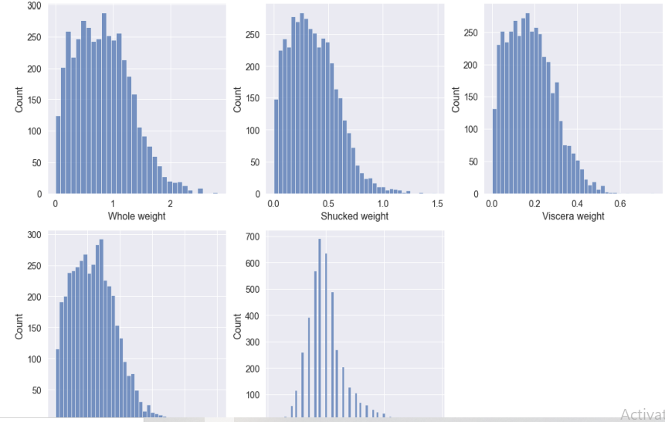∙

Bi-Variate Analysis

***#Bivariate analysis***

**import** matplotlib.pyplot **as** plt

*#create scatterplot of hours vs. score*

plt**.**scatter(data**.**Height, data**.**Diameter)

plt**.**title('Height vs Diameter')

plt**.**xlabel('Height')

Plt**.**ylabel

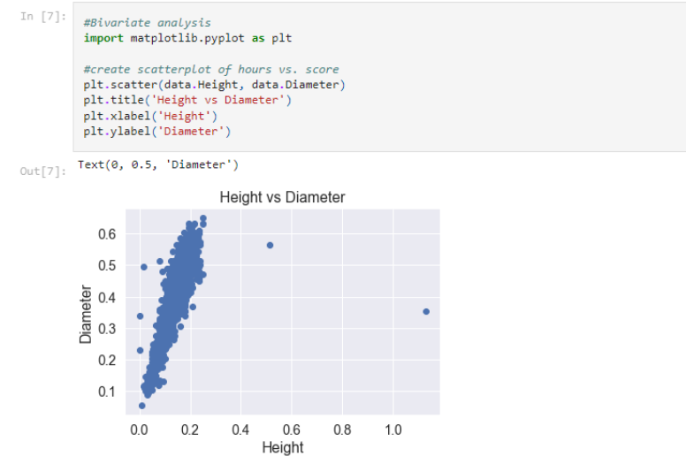

Multi-Variate Analysis

***#multivariate analysis***

sns**.**pairplot(d)

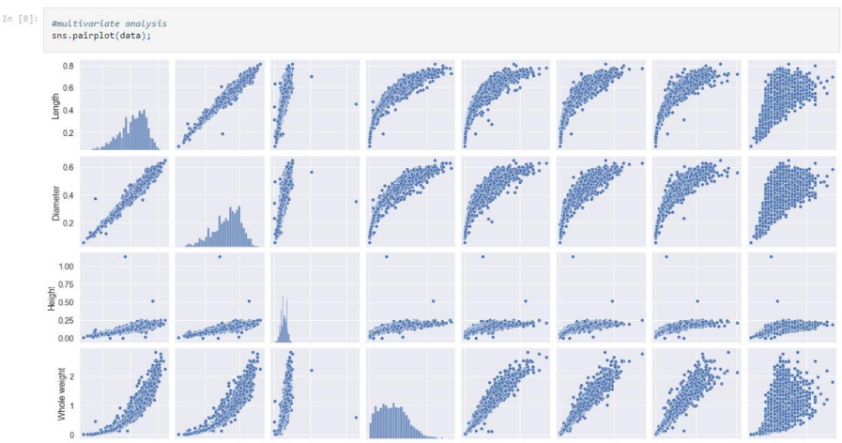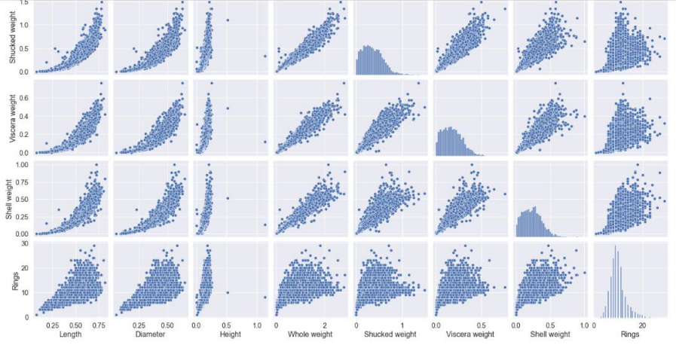

4. Perform descriptive statistics on the dataset

data**.**mean()

data**.**median()

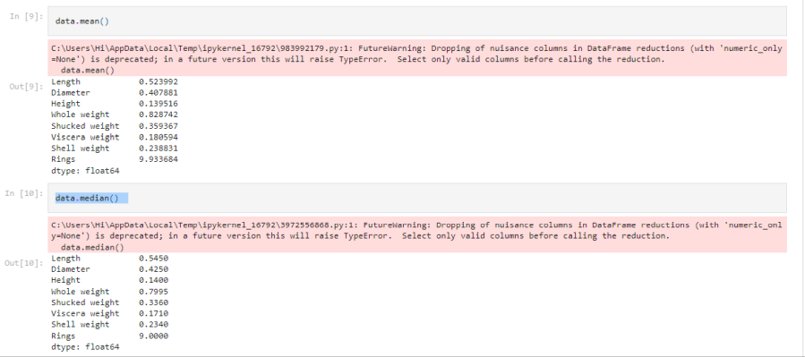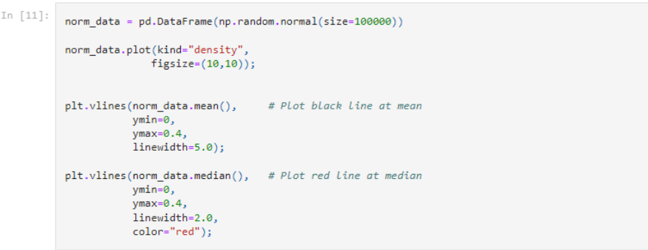

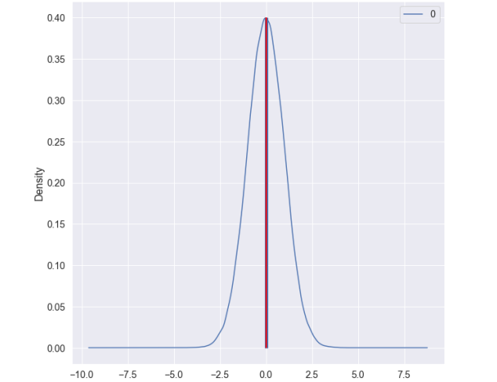

5. Check for Missing values and deal with them.

***#identifying the missing value***

df **=** pd**.**DataFrame(data)

df**.**isnull()

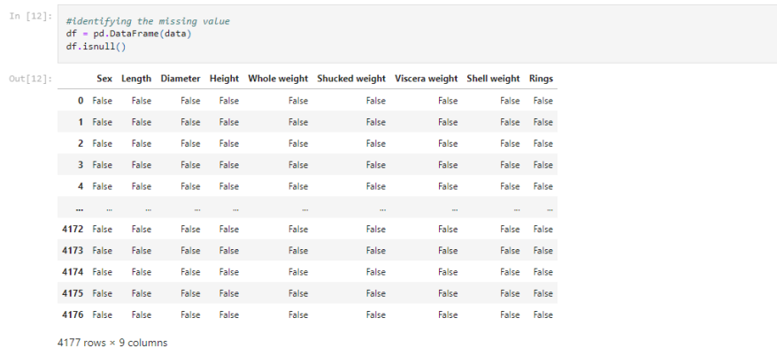

***#filling the missing value with previous value***

df**.**fillna(method **=**'pad')

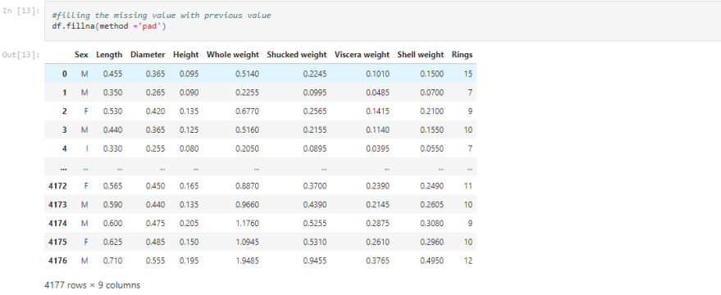

***#filling null values in missing values***

data[0:]

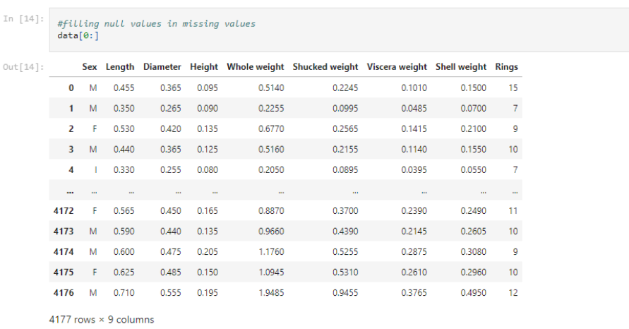6. Find the outliers and replace them outliers

***#identifying the outliers***

print(df['Shell weight']**.**skew())

df['Shell weight']**.**describe()

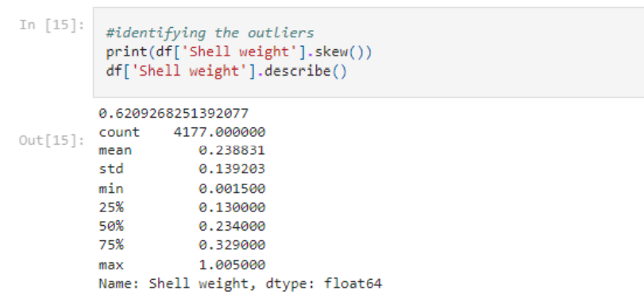***#replacing the outliers***

print(df['Shell weight']**.**quantile(0.50))

print(df['Shell weight']**.**quantile(0.95))

df['Shell weight'] **=** np**.**where(df['Shell weight'] **>** 325, 140, df['Shell weight']) df**.**describe()

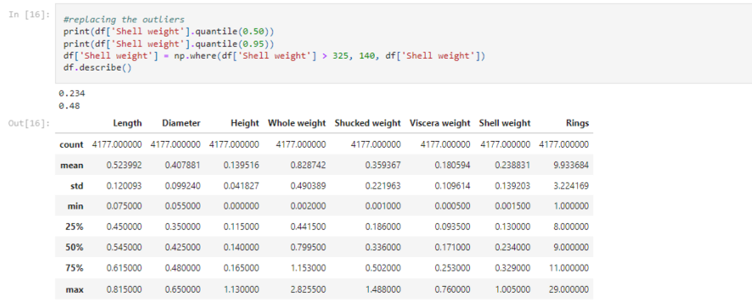7. Check for Categorical columns and perform encoding.

***#perform encoding***

**from** sklearn.compose **import** make_column_selector **as** selector

categorical_columns_selector **=** selector(dtype_include**=**object)

categorical_columns **=** categorical_columns_selector(data)

categorical_columns

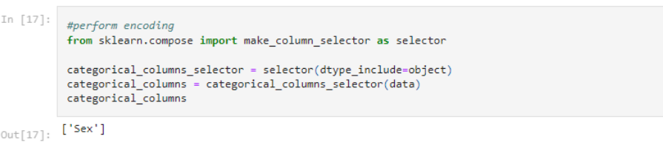

data_categorical **=** data[categorical_columns]

data_categorical.head()

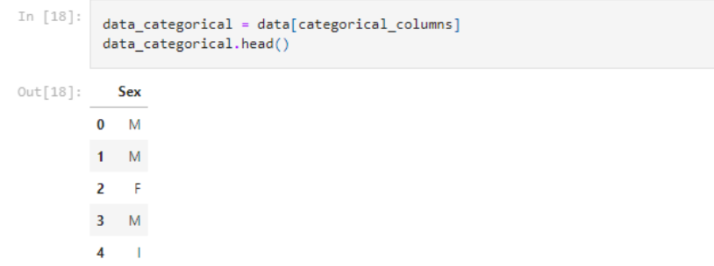

8. Split the data into dependent and independent variables.

**from** sklearn **import** preprocessing

***# label_encoder object knows how to understand word labels.***

label_encoder **=** preprocessing**.**LabelEncoder()

***# Encode labels in column 'species'.***

df['Sex']**=** label_encoder**.**fit_transform(df['Sex'])

df['Sex']**.**unique()

X= data.iloc[ : , :-1].values

y= data.iloc[ : , 4].values

print(X,y)

*# import packages*

**import** numpy **as** np

**import** pandas **as** pd

**from** sklearn.model_selection **import** train_test_split

*# importing data*

print(df**.**shape)

*# head of the data*

print('Head of the dataframe : ')

print(df**.**head())

print(df**.**columns)

X**=** df['Whole weight']

y**=**df['Shucked weight']

*# using the train test split function*

X_train, X_test, y_train, y_test **=** train_test_split(

X,y , random_state**=**104,test_size**=**0.25, shuffle**=True**)

*# printing out train and test sets*

print('X_train : ')

print(X_train**.**head())

print(X_train**.**shape)

print('')

print('X_test : ')

print(X_test**.**head())

print(X_test**.**shape)

print('')

print('y_train : ')

print(y_train**.**head())

print(y_train**.**shape)

print('')

print('y_test : ')

print(y_test**.**head())

print(y_test**.**shape)

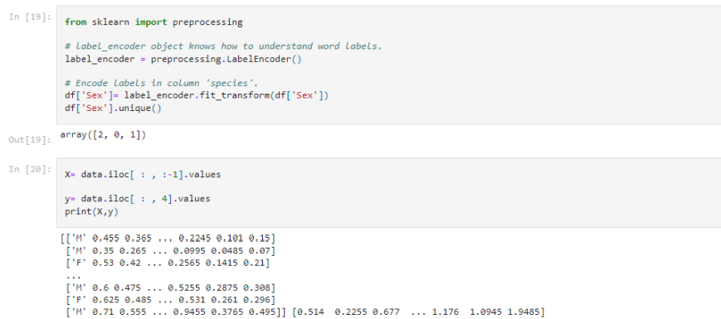

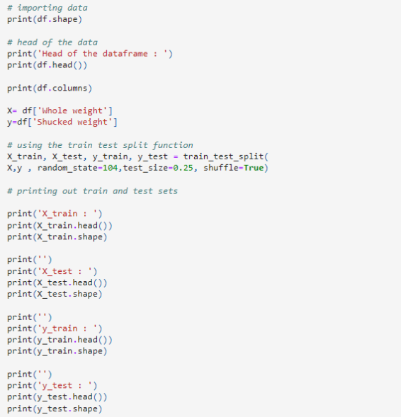

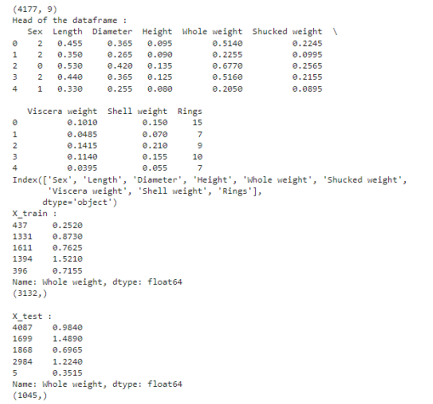

9. Scale the independent variables

*#scaling*

df_scaled = df.copy()

col_names = ['Shucked weight', 'Whole weight']

features = df_scaled[col_names]

from sklearn.preprocessing import MinMaxScaler

scaler = MinMaxScaler()

df_scaled[col_names] = scaler.fit_transform(features.values)

from sklearn.preprocessing import MinMaxScaler

scaler = MinMaxScaler(feature_range=(5, 10))

df_scaled[col_names] = scaler.fit_transform(features.values)

df_scaled

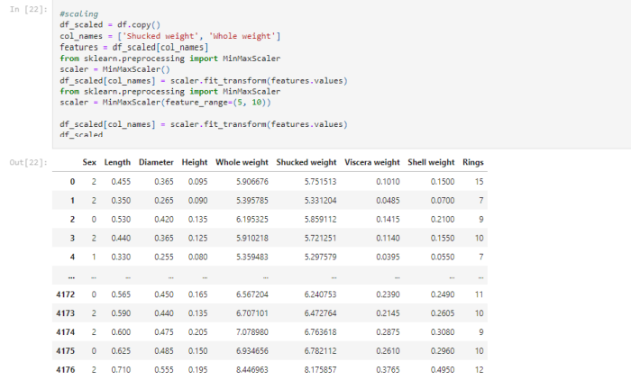

10. Split the data into training and testing

***#testing and training***

X **=** df**.**iloc[:, :**-**1]

y **=** df**.**iloc[:, **-**1]

***# split the dataset***

X_train, X_test, y_train, y_test **=** train_test_split(

X, y, test_size**=**0.05, random_state**=**0)

print(X_train, X_test, y_train, y_test)

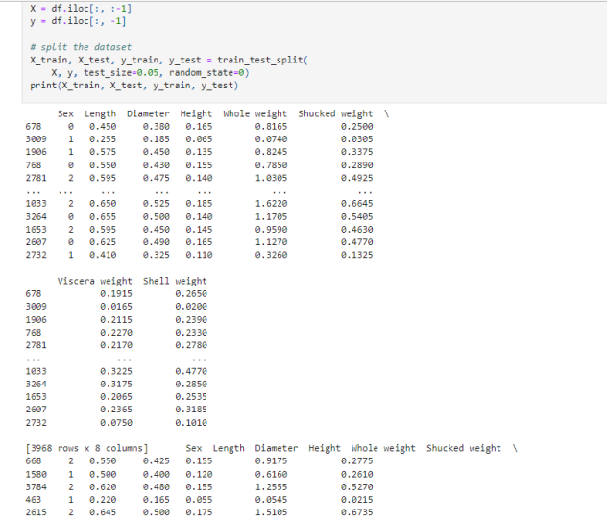

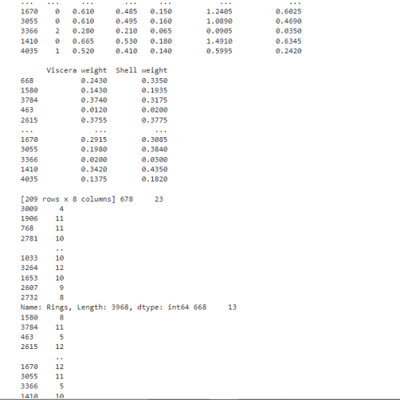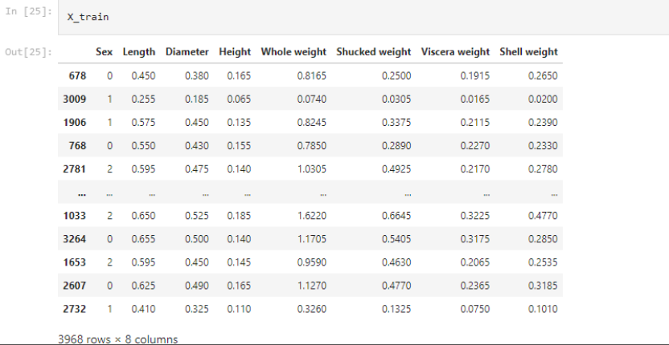

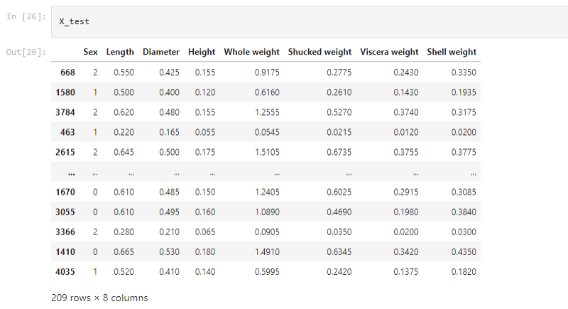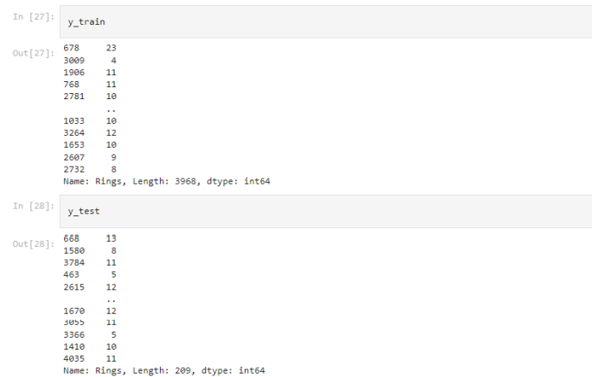

11. Build the Model

***# Evaluate the model on the test data***

predictions **=** model**.**predict(X_test)

predictions

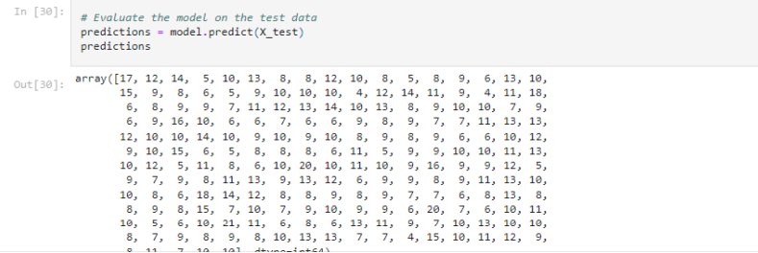12. Train the Model

***# Select algorithm***

**from** sklearn.tree **import** DecisionTreeClassifier

**from** sklearn.metrics **import** accuracy_score

model **=** DecisionTreeClassifier()

***# Fit model to the data***

model**.**fit(X_train, y_train)

***# Check model performance on training data***

predictions **=** model**.**predict(X_train)

print(accuracy_score(y_train, predictions))

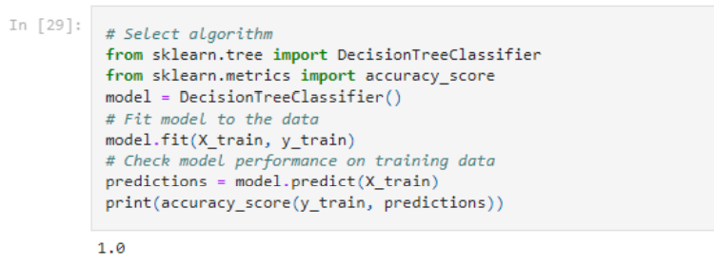

13. Test the Model

***# Evaluate the model on the test data***

predictions **=** model**.**predict(X_test)

predictions

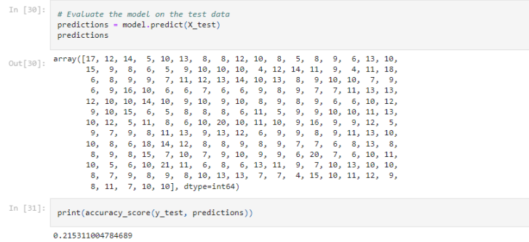

14. Measure the performance using Metrics.

**import** os

os**.**environ["PATH"] **+=** os**.**pathsep **+** 'C:/Program Files (x86)/Graphviz2.38/bin' from sklearn.metrics import confusion_matrix

from sklearn.metrics import accuracy_score

from sklearn.metrics import classification_report

from sklearn.metrics import roc_auc_score

from sklearn.metrics import log_loss

X_actual = [1, 1, 0, 1, 0, 0, 1, 0, 0, 0]

Y_predic = [1, 0, 1, 1, 1, 0, 1, 1, 0, 0]

results = confusion_matrix(X_actual, Y_predic)

print ('Confusion Matrix :')

print(results)

print ('Accuracy Score is',accuracy_score(X_actual, Y_predic))

print ('Classification Report : ')

print (classification_report(X_actual, Y_predic))

print('AUC-ROC:',roc_auc_score(X_actual, Y_predic))

print('LOGLOSS Value is',log_loss(X_actual, Y_predic))

